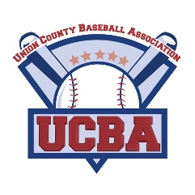
Union County Baseball Association
www.ucba-nj.org
Player Registration Form
Checks made payable to: UCBA

Player Name
Address
Date of Birth
Email
Phone

Division MINOR MAJOR TEEN
(select one)
Shirt Size Youth: S M L XL
(select one) Adult: S M L XL

Address
City/State/Zip
Emergency Contact #1
Name
Phone
Email

Emergency Contact #2
Name
Phone
Email
Age

Medical Information
Please list any physical limitations (allergies, hearing, sight, etc.)
- I/We, the parents/guardians of the above-named child for a position on a UCBA team, hereby give my/our approval to participate in any and all UCBA activities.
- I/We know that participation in baseball may result in serious injuries and protective equipment does not prevent all injuries to players, and do hereby waive, release, absolve, indemnify, and agree to hold harmless the UCBA, UCBA Staff, the organizers, sponsors, supervisors, and participants, from any claim arising out of any injury to my/our child whether the result of negligence or for any other cause.
- I/We will furnish a certified birth certificate of the above-named candidate to League Officials.

x

Signature of Parent/Guardian Date
DO NOT WRITE BELOW THIS LINE – LEAGUE USE ONLY
PAID □ TEAM ASSIGNED □
BC □
Summer Registration Form Rev. 2/19
Rev. 10/18

